**Istio**

<https://istio.io/latest/docs/setup/getting-started/>

**Download Isito**

**Step1: Start minikube**

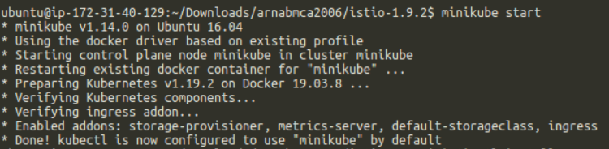

**Step1: Download and extract the latest release automatically (Linux or macOS):**

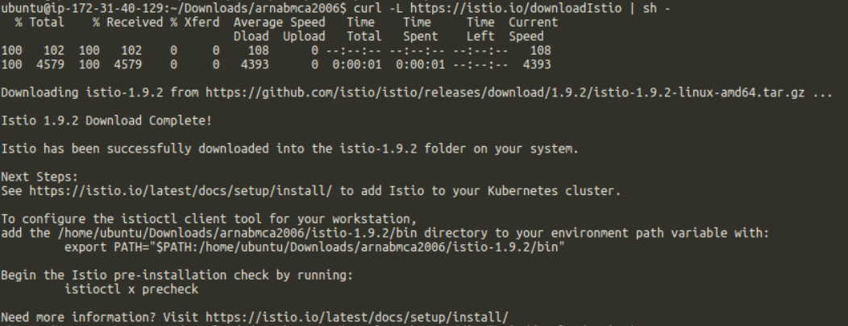

**Step2: Move to the Istio package directory**



**Step3: Add the istioctl client to your path (Linux or macOS):**



**Install Istio**

**Step1: For this installation, we use the demo configuration profile. It’s selected to have a good set of defaults for testing, but there are other profiles for production or performance testing.**



**Step2: Add a namespace label to instruct Istio to automatically inject Envoy sidecar proxies when you deploy your application later:**



**Deploy the sample application**

**Step1: Deploy the Bookinfo**

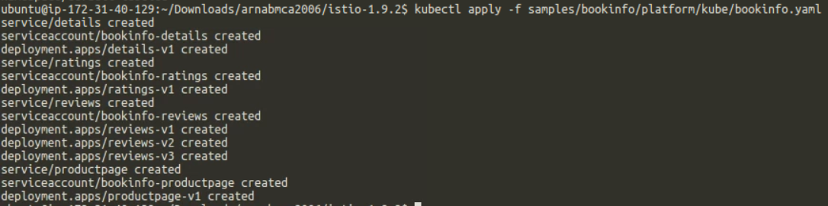

**Step2: The application will start. As each pod becomes ready, the Istio sidecar will be deployed along with it.**

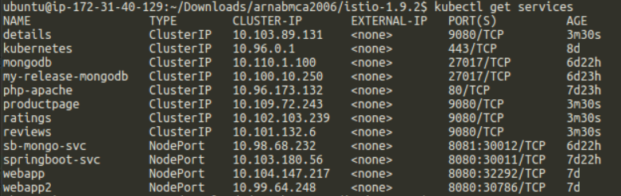

and

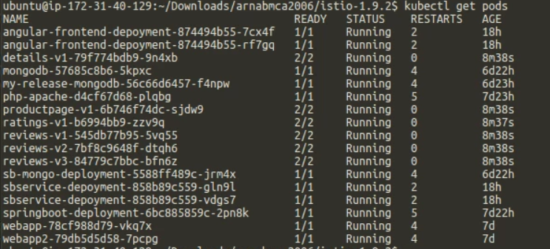

**Step3: Verify everything is working correctly up to this point. Run this command to see if the app is running inside the cluster and serving HTML pages by checking for the page title in the response:**



**Open the application to outside traffic**

The Bookinfo application is deployed but not accessible from the outside. To make it accessible, you need to create an [Istio Ingress Gateway](https://istio.io/latest/docs/concepts/traffic-management/#gateways), which maps a path to a route at the edge of your mesh.

**Step1: Associate this application with the Istio gateway:**



**Step2: Ensure that there are no issues with the configuration:**

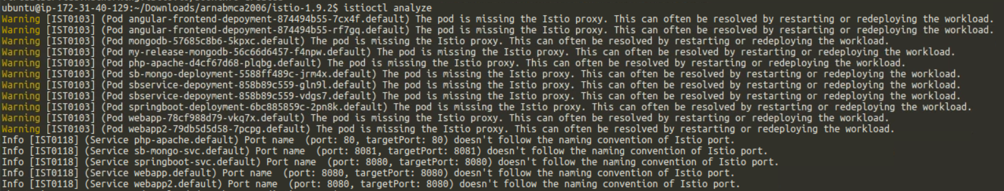

**Determining the ingress IP and ports**

**Step1: Set the ingress ports:**



**Step2: Ensure a port was successfully assigned to each environment variable:**

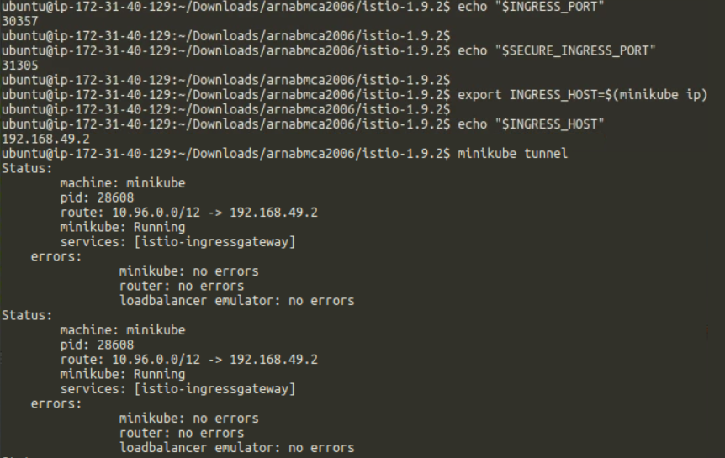

**1. Set GATEWAY_URL:**

**2. Ensure an IP address and port were successfully assigned to the environment variable:**



**Verify external access**

Confirm that the Bookinfo application is accessible from outside by viewing the Bookinfo product page using a browser.

**Step1: Run the following command to retrieve the external address of the Bookinfo application.**



**Step2: Paste the output from the previous command into your web browser and confirm that the Bookinfo product page is displayed.**

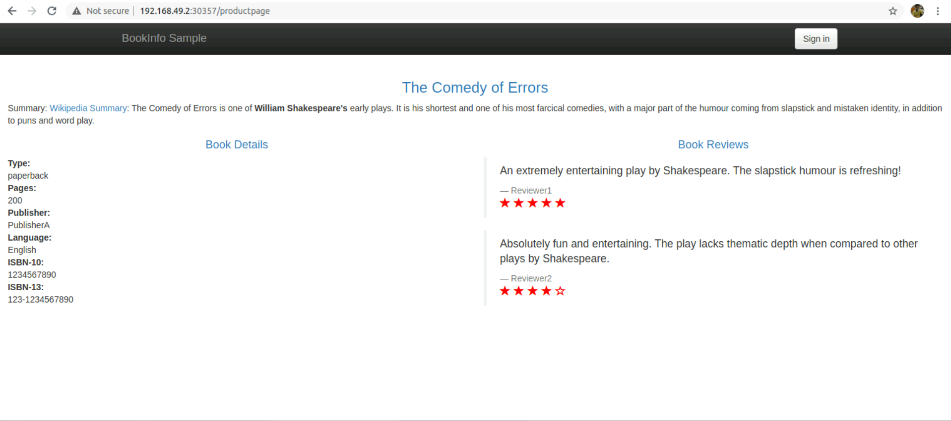

**View the dashboard**

Istio integrates with several different telemetry applications. These can help you gain an understanding of the structure of your service mesh, display the topology of the mesh, and analyze the health of your mesh.

Use the following instructions to deploy the Kiali dashboard, along with Prometheus, Grafana, and Jaeger.

**Step1: Install Kiali and the other addons and wait for them to be deployed.**

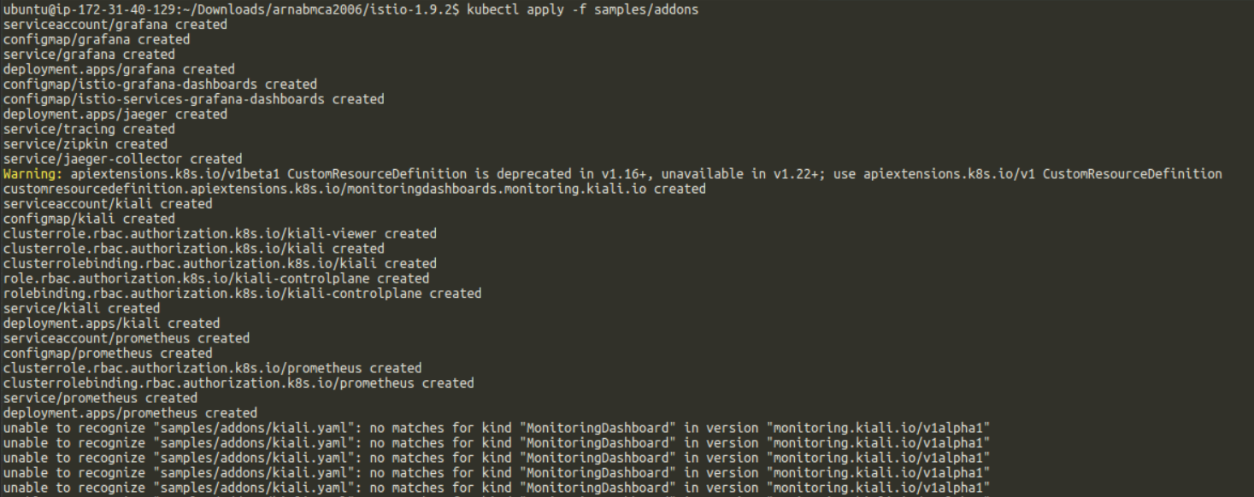



**Step2: Access the Kiali dashboard.**



**Step3: In the left navigation menu, select Graph and in the Namespace drop down, select default. The Kiali dashboard shows an overview of your mesh with the relationships between the services in the Bookinfo sample application. It also provides filters to visualize the traffic flow.**

